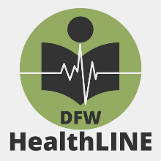
HealthLINE Meeting – July 13, 2023
Virtual Zoom Meeting

For questions concerning registration or technical issues, contact
Jane.Scott@UTSouthwestern.edu or Jon.Crossno@UTSouthwestern.edu

Agenda
9:00-9:40
Business Meeting
Call to order
Introductions
Approval of Minutes from Previous Meeting

Old Business
Secretary’s Report: Kristin Hannappel
Treasurer’s Report: Mary Anne Fernandez
Archives Committee Report: Shelia Bickle
Communications Committee Report: Jon Crossno
Mentoring Committee Report: Alysha Sapp
Membership Committee Report: Jamie Quinn

New Business
ILL Statistics
Travel Award Committee: Brook Amen, Eva Osbourne, and Alysha Sapp
Deadline: August, Monday August 14 [https://dfwhealthline.org/awards]
MLA/Conference experience share back
Increase/Reengage Membership Goal
Nomination Committee: Jane Scott

Announcements:
Available Job Positions and Job Changes
Institutional Announcements/Changes
Recognitions

Adjourn
Break
9:50am-10am
Program
10:00am – 10:20am Alysha Sapp – Research Journey
10:20am – 10:55am Large group discussion
10:55am – 11:00am Meeting Closing Remarks

